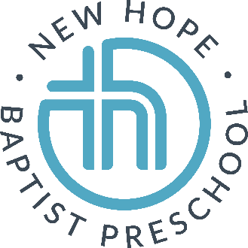

919-954-9684
preschool@newhoperaleigh.org

Annual Registration: $200 for the 1st child, $150 for each additional child

Monthly Price List for 2021-2022

TODDLER/TWOS 3 DAYS (M, T, TH) $270
4 DAYS (M-TH) $295

THREES 3 DAYS (M, T, TH) $270
4 DAYS (M-TH) $295

FOURS 4 DAYS (M-TH) $295

A 10% discount will be given off monthly tuition for additional siblings OR military families.
Registration is non-refundable. One discount per family, for a maximum discount of 10%.

Students should pack a water, healthy snack and lunch. We are a peanut-free school.

School Schedule: 9:15 to 1:00, with staggered dismissal beginning at 12:45

