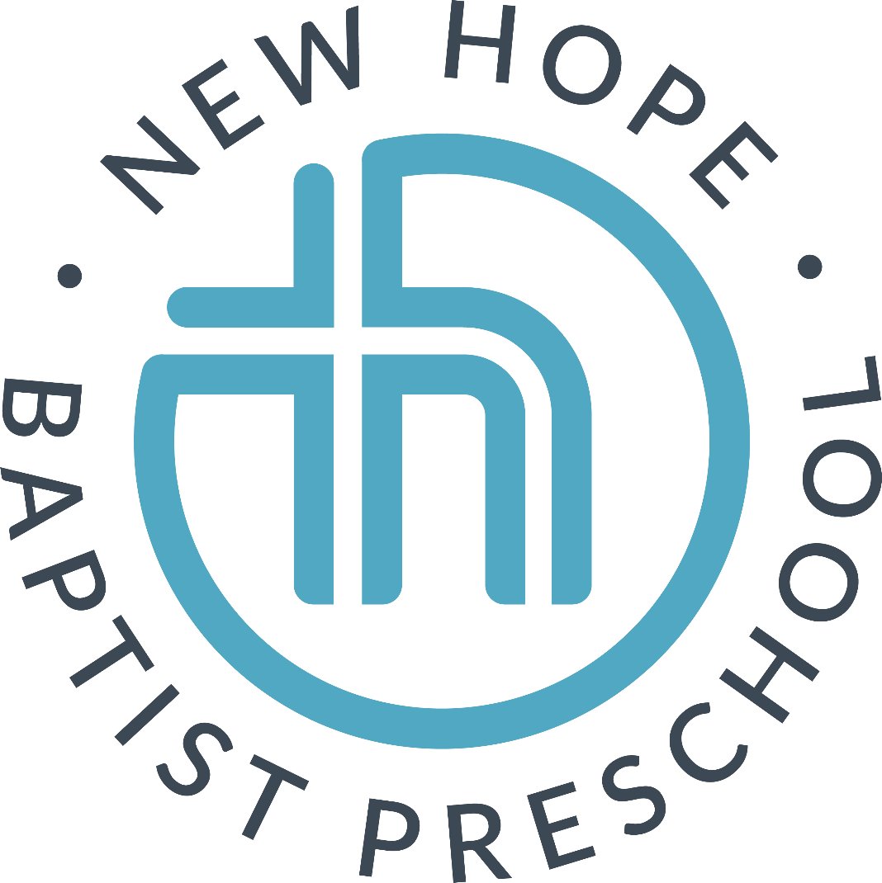

Parent Handbook

New Hope Baptist Preschool
A ministry of New Hope Baptist Church
4301 Louisburg Road
Raleigh, NC 27604
Email: Preschool@newhoperaleigh.org
Phone: 919-954-9684

WELCOME

Dear Preschool Families,

On behalf of the staff of New Hope Baptist Preschool, we welcome your family to our school. We are honored to take part in these early stages of your child’s development. It is a pleasure to have you join our preschool family and we look forward to meeting, guiding, and teaching your child.

Thank you for the faith you put in our efforts to ensure that your child will thrive as he or she develops socially, spiritually, physically, emotionally, creatively and in academic readiness this year. Our program is designed to nurture and educate children through play and to build community amongst our preschool staff and families.

I hope that you will find this handbook helpful. It includes useful information and policies that you may need to reference throughout the year. Please save your handbook for future reference.

Blessings,

Nicole Flores
Director
New Hope Baptist Preschool
preschool@newhoperaleigh.org

PURPOSE AND PHILOSOPHY

New Hope Baptist Preschool is a ministry of New Hope Baptist Church. We are a non-profit organization and our mission is to provide a spiritually nurturing environment where children are able to explore and learn about God’s world while developing spiritually, socially, emotionally, creatively, cognitively, and physically. Parents are encouraged to participate in the education of their child through visits, volunteer time, conferences, field trips, chapel, and special events.*

New Hope Baptist Preschool is under the guidance of the New Hope Baptist Church preschool committee. This committee serves as a liaison between the preschool and the governing boards of New Hope Baptist Church.

New Hope Baptist Church has a rich heritage from its organization in 1832. You are invited to visit the church anytime! Worship is on Sundays at 10 AM and is in person or live-streamed on Facebook.

Dr. Randy Carter, Pastor
Rev. Brian Lockamy, Associate Minister for Students
Ms. Lori Welborn, Minister for Children and Community Outreach

*Per CDC/NCDHHS recommendations, we must limit visitors/volunteers at NHBP. Activities that require parents to be in a classroom are suspended at this time.
ENROLLMENT/ADMISSION

NHBP enrolls students based on classroom availability throughout the school year. New students must adhere to the following guidelines for enrollment:
• Complete and submit an enrollment application
• Provide emergency contact information
• Sign applicable permission slips
• Submit registration fee and tuition payments applicable
• Provide up to date immunization records
• Notify the school of any health or developmental concerns
• Children in the 3’s and 4’s classes must be toilet trained before they can begin school

Children are assigned their class based on their age on August 31 of that year. Enrollment can only be confirmed with receipt of the Registration Form and Registration Payment.

The preschool and the church do not discriminate on the basis of race, religion, or national origin. The school may not be equipped or staffed to meet the needs of children with severe handicaps, learning disabilities or health problems. Each situation will be reviewed on an individual basis and every possible accommodation effort will be made.

Priority Registration for a new school year will be given in the following order:
- Children of New Hope Baptist Church members who are currently enrolled in the preschool
- Currently enrolled children
- Siblings of children who are currently enrolled
- Children of New Hope Baptist Church members
- Siblings of previously enrolled children
- General public

Enrollment of a child shall be discontinued for the following reasons:
- The school is unable to meet the child’s needs or the child is unable to adjust to the program
- Delinquency in payment of tuition fees
- Failure to maintain current enrollment information, including emergency data
- Disregard of program policies and procedures
- Uncooperative with preschool staff or philosophy

HEALTH REQUIREMENTS

NHBP requires that all children enrolled receive all of the recommended vaccines according to the schedule published by Center for Disease Control and American Academy of Pediatrics. Your child’s immunization record must be on file at the preschool before beginning school.

TUITION / WITHDRAWALS

Tuition payments will be made 9 times a year, September 1 through May 1. Tuition is due on the first day of each month. The following forms of payment are accepted:
- Check made out to New Hope Baptist Preschool (put child’s name in the memo line)
- POS Credit Card Transaction (2.75% processing fee will apply)
- Automatic draft by ACH
- Automatic draft by credit card (2.75% processing fee will apply)
- Cash (please put in an envelope with your child’s name)

Payments can be sent in your child’s backpack or given directly to the director. Payments will not be accepted during morning carpool, but can be accepted during afternoon pick up or brought to the office during office hours. Any payment not received by the 5th of the month it is due will be subject to a late fee of $25.00. See late fee policy for details. There is a $35 charge for returned checks or NSF payments.

Thirty days written notice is required for all withdrawals. With 30-day notice, pre-paid tuition may be refunded. Without 30-day notice, all monies paid will be retained by the school. In the event of an extended absence, families must continue to pay monthly tuition to hold your child’s slot in their classroom.

Tuition is calculated as an annual payment that is divided into 9 monthly payments. Tuition fees are not pro-rated for partial weeks, attendance, holidays, teacher workdays, or inclement weather. Please see the Covid policy for any extended closures due to the national pandemic.

DRESS and LUNCH

Children are encouraged to wear play clothes and athletic shoes. Daily activities include active and messy play and we want the children to feel comfortable enough to enjoy themselves without worrying about their clothes. We also are concerned about the children’s safety on the playground. Closed-toe and closed-heel shoes are required. Your child’s name should be placed on all outer clothing and other belongings to help ensure the return of all possessions and clothes. Also, book bags should be large enough to transport artwork and coats to and from school.

Parents will send a healthy lunch to school with their child each day. Snacks will be either individual (parents send an individual snack) or communal (parents will send in bigger packages for the class to share). This is determined by each teacher. We are a peanut-free environment.

CARPOOL and PICK-UP

Morning carpool and afternoon pick-up take place in the large parking lot off New Hope Rd. Please do not come to the smaller preschool parking lot off Louisburg Road during carpool times (9:15-9:30 and 12:45-1:05). The preschool office and front door are closed and locked at these times, and no exceptions can be made to this policy.

Morning Carpool runs from 9:15 - 9:30. *Please do not line up before 9:10, as another program uses the carpool line before us.* If you arrive after 9:30, you will need to bring your child to the preschool office by using the parking lot off Louisburg Road. Morning Route: Enter the large parking lot through the entrance on New Hope Road. Pull up in front of the preschool carpool/coned off spaces.

Afternoon Pick-up will begin at 12:45 PM. For afternoon pick-up, parents will park their car in a parking space and walk to the courtyard area for their children. Please do not park in the carpool line, as there is too much risk to the children if we allow parking in this area. Each class will be informed of its individual dismissal time and the children in each class will have a 5 minute window for dismissal.

Please be on time to drop off and pick up your child from school. Remember that they are eager to see you and inform you of the exciting day that they have had at preschool! Any child picked up five minutes after their carpool period will be subject to a $20 late fee. Please see late fee policy for more details.

For the safety of all children and staff, NHBP requires that parents follow the guidelines listed in this policy for carpool. Disregarding these policies creates an unsafe environment for the children. Parking lot locations are marked on the map provided below.

Carpool Etiquette:
• Please be a team player and follow the assigned carpool route! Entering and exiting in areas other than those outlined here clogs the parking lot for us and for other church visitors. Be mindful that our preschool is not the only event or program happening on the church property.
• Please do not use cell phones in the carpool line.
• Please wait until the car in front of you exits the line—do not pull around vehicles in line.

If someone other than the parent or designated adult whose name appears on the pick-up section of on the Registration Form or Student Information Card is picking up a child, the parent must notify the preschool in writing. We can not release a child to anyone without prior written authorization.

**As a covid precaution, parents or visitors will not be able to enter the preschool. If you need to drop your child off late or pick up your child early, you will be asked to wait in the lobby. Please wear a mask anytime you visit the preschool.

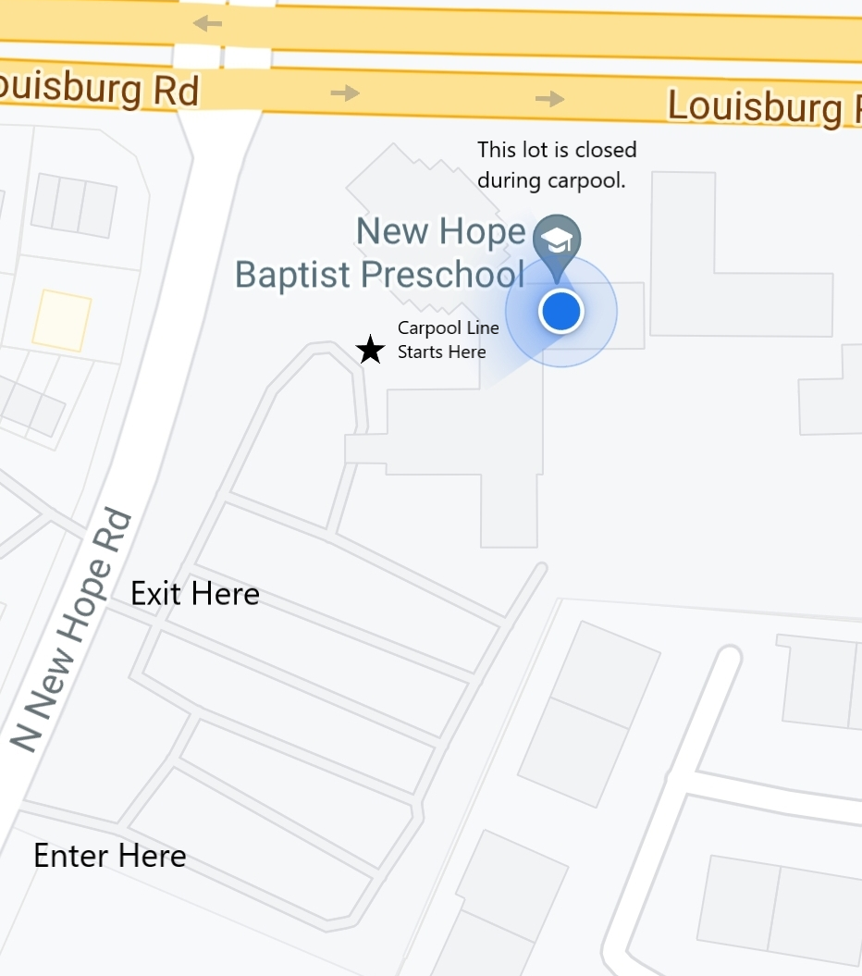

GENERAL GUIDELINES FOR ILLNESS

Children should be healthy enough to fully participate in all the activities of the preschool day to attend school. If your child experiences any of the following symptoms/conditions in the 24 hours before the school day, they must stay home!
*Oral temperature of 100 degrees or higher. Your child should be fever free for 24 hours without medication before returning to school.
*Yellow, green, or excessive nasal drainage
*Hard cough or cough with yellow or green mucous
*Diarrhea, loose stools, or vomiting
*Rashes that have not been diagnosed by a physician or have been diagnosed and considered contagious
*Any skin infection such as impetigo, boils, or ringworm until treated for 24 hours.
*Hand, Foot and Mouth symptoms/diagnosis
*Conjunctivitis (pink eye)/ a red eye with white or yellow eye discharge, until 24 hours after treatment has started
*Strep throat, until 24 hours after treatment has started
*Scabies or lice

CHILDREN MUST BE SYMPTOM FREE WITHOUT MEDICATION FOR AT LEAST 24 HOURS BEFORE RETURNING TO SCHOOL.

By helping us to observe good health standards, you will be protecting the health of your child, the other children attending preschool, and our staff members. Any individual medical concerns should be discussed with the preschool director and your child’s teacher. If your child is home due to illness, please let us know at preschool. Please see the most current covid policy for additional information.

SIBLING POLICY: If a child in your home is sick with any contagious infection, please keep all siblings home until symptoms resolve, even if they do not display symptoms. This will help reduce the spread into other classrooms.

MEDICATION and EMERGENCIES

No medication can be administered at the preschool, including sunscreen and bug spray. This is for the safety of our students and staff. If a child requires and EpiPen, their parent will need to complete a permission form allowing the preschool staff to administer a treatment if needed and to discuss appropriate action in case of an emergency.

Parents or gaurdians must complete a new Emergency Medical Card each year. Please inform the preschool of all allergies on your Emergency Card.

Parents will be notified of accidents or injuries at pick-up, or at the time of the accident depending on the severity of the injury. Minor injuries will be treated (band-aid, ice packs) as needed.

DISCIPLINE POLICY

It is the philosophy of New Hope Baptist Preschool that discipline is an integral part of learning. Putting that philosophy into action, we seek through positive and consistent guidance to:
• Help children learn self-control which enables them to interact well with others.
• Promote socially acceptable behavior
• Aid in the development of self-confidence and high self –esteem.
• Help children develop problem solving skills to find their own solutions.

It is our policy that under no circumstances will corporal punishment be administered by our staff. Techniques which are frightening or humiliating to a child, such as punishment associated with food, rest, or toileting, as well as rough handling of a child (spanking, shaking or pushing) are not a part of our program. No verbal abuse, intimidation or fear tactics will be used. When a child does experience difficulty in the classroom and does not respond to a positive intervention, teachers use brief periods of appropriately supervised quiet time or time out. When the behavior ceases, the child may return to the group and rejoin the classroom activity.

Behavioral Intervention
If behavior problems persist, the preschool staff seeks to utilize strategies for behavior management and the local resources available to help children learn appropriate behavior for the classroom. For ongoing behavior issues in the classroom, the following steps will be taken:
• Parents will be brought in for a conference to discuss the behaviors and create a plan for intervention • Teachers will utilize their training in Triple P, Conscious Discipline, and other positive discipline techniques to aid in helping each child be successful in the classroom.
• Outside resources will be utilized, typically beginning with a Teacher- Parent Consultation from Project Enlightenment, a Wake County Public Schools service that provides classroom observation and assistance for parents and teachers.
• If recommended, developmental or social/emotional evaluation for the child to determine any other needs to be addressed
• Implementation of recommended services based on any observations/screenings conducted.

For all strategies and steps listed, we require the full participation and cooperation of the parents so that safety can be maintained in all our classrooms. We seek to be inclusive and accommodating to all children, and only through cooperation between home and school can this occur! Aggressive behavior that transcends standard disciplinary measures will be reviewed by the Preschool Director and Preschool Committee on a case-by-case basis. New Hope Baptist Preschool reserves the right to require additional parent involvement and review to maintain a child’s placement in the preschool program.

BITING

Biting is, unfortunately, not unexpected when children are in a group setting. It is estimated that up to one half of preschoolers will bite another child at some point. If a child is bitten, parents of the bitten child and parents of the child who bit will be notified. The name of the children who bit will remain confidential. Our preschool employs prevention techniques and strategies to reduce biting. If we experience ongoing biting by one child, we will develop a plan with the parents to work on the issue.
PARENT – TEACHER COMMUNICATION

School wide and classroom newsletters will come to your home by e-mail at the beginning of each month. Other classroom reminders and school-wide announcements will be sent by e-mail as needed. Please read these publications carefully and post important dates on your home calendars. Feel free to call the preschool with any type of question and speak with your child’s teacher during pick-up time. Please save more detailed questions for afternoon pick-up, rather than in morning carpool, so we don’t cause carpool delays.

*School wide parent-teacher conferences will be offered in the spring. Use this time to discuss your child’s progress and experience in their classroom. Conferences may be scheduled at other times by the teacher, parent, or director. Our staff is always willing to spend time with you to discuss joys or concerns you may have regarding your child.

BIRTHDAYS

We enjoy celebrating birthdays in the classroom. Please contact your child’s teacher before sending in snacks or goodies for the class. All snacks should be store bought and be mindful of any allergies present in your child’s classroom. Children with summer birthdays can also be recognized, so please communicate with your child’s teacher should you like to arrange this for your child!

Please do not send invitations to school unless your child is inviting his/her whole class to a party.

LATE FEE POLICIES

Tuition payments are due on the first day of each month with the first month’s tuition payment due on the first day of each month. A late fee of $25 is to be charged for tuition payments received after the 5th day of the month in which tuition is due. If the 5th of the month falls on a weekend, tuition payments will be considered late if not received on the preceding Friday. Late fees should be paid upon payment of tuition. Late fees must be paid by the end of the calendar month in which they are assessed in order for the child to be eligible to return to school the following month. If payment of tuition is not received by the last day of the month in which it is due, automatic termination of enrollment may follow. Extenuating circumstances must be brought to the attention of the preschool director.

Afternoon pick up will begin at 12:45 PM. Each class will be notified of the specific dismissal time for their class, with a 5 minute window. Any child picked up 5 minutes after their class dismissal window will be subject to a $20 late pick up fee. Parents must call the preschool if they will be late for pick up so that arrangements can be made to supervise the children until they can be picked up. Late pick-up beyond 1:15 will be charge the $20 late pick up fee, plus $2 per minute. Extenuating circumstances must be brought to the attention of the preschool director.

INCLEMENT WEATHER POLICY

When the Wake County Public Schools close due to inclement weather, NHBP will close. If preschool is in progress and Wake County Schools close, you will need to pick up your child immediately.

If the Wake County Schools open with a one or two hour delay, we will open with a one hour delay at 10:15 AM. All pick up times remain the same. If Wake County Schools open with a three hour delay, New Hope Baptist Preschool will be closed.

If the Wake County Schools are closed for an extended period of time, the preschool director reserves the right to hold preschool if conditions permit. You will be contacted by the director via phone or e-mail if the preschool is holding class when the Wake County Schools are closed.

If the Wake County Schools close due to excessive heat, NHBP will be open.

NHBP policy regarding weather make up days: The first four days missed due to inclement weather are not made up, as they are built into the preschool calendar. The second three days will be made up on days scheduled by the preschool committee. Any additional inclement weather days will be forgiven and no additional make up days will be scheduled. No refund is given for days missed. Please see the most recent covid policy for covid-related closings.

PROGRAMS

Grouped by age, the curriculum for each age level is designed to meet the needs of the individual child and abilities at his/her particular age and developmental level. Children are enrolled in each class based on their age at August 31st at the start of each school year.

Toddler/Two Year Olds: This program is designed to provide types of activities that suit the developmental needs of each child. Daily schedules are repetitive, building on the 2's need for consistency. Included in the day are times for solitary/parallel play and short circle/story times. The 2's explore their world through touch, taste, feel, and hands-on experiences. Toddlers must be 16 months or older to enroll in this class.

Three Year Olds: The Three Year Old Program begins to expand the child’s world through hands-on experiences and increased opportunities for physical, intellectual, and spiritual growth. Center time is provided each day for your child to explore the world and begin to establish social relationships. Opportunity to further expand speech and vocabulary are provided each day through diverse classroom activities. Children must be toilet trained in the three year old class.

Four Year Olds: Our two four year old classes, offered on a 4-day schedule only, provide children with learning experiences needed to prepare for kindergarten. Each day children are able to utilize the centers, activities, and play experiences offered to develop the academic and social skills they need to be successful in kindergarten. Children practice literacy and writing skills, math concepts, science and nature activities, and much more through this classroom. In this classroom, teachers provide the early learning and social teaching necessary to prepare for kindergarten! Children must be toilet trained in the four year old class.
We believe preschoolers learn best through play and offer an enjoyable program that encourages creativity and a lifelong love of learning. Our Christianity is taught through the love shown by our staff for each other and the children. Our teachers are experienced and knowledgeable in the area of child development and love and understand the young child. Each staff member continues her academic training by attending workshops and courses related to early childhood education and development.

WHAT DO WE DO IN PRESCHOOL?

Circle time is a group gathering during which we share our ideas, plans, and observations. Circle activities are designed to stimulate each child’s thinking, enrich their social skills, and expand their attention spans.

Gross-motor activities give children the opportunity to use their muscles – as well as their imaginations – as they engage in fun, healthy exercises such as running, jumping, and climbing. Fine-motor activities help improve small muscle development and eye-hand coordination. Some common items found in the fine-motor/manipulative area include puzzles, beads and laces, pegboards, crayons, and scissors. Art activities help children creatively express their thoughts and feelings. They help reinforce fine-motor skills and concept development in areas such as colors, shapes, and size relationships.

Dramatic play activities help children express themselves, practice life skills, improve social skills, increase self-esteem, build vocabulary, and solve problems. And dramatic play is just plain fun!

Music activities promote good listening skills, creative expression, and social skills. In music, children can explore sound, volume, tempo, and rhythm—which are building blocks for higher level math skills!

Science activities offer children many hands-on opportunities for observation, exploration, investigation, making predictions, and experimentation. Sand and water activities allow children to experiment with textures and the properties of different substances. Children can explore positional concepts and measurements, expanding their understanding of early math concepts. This is also a valuable exploration of their senses!

Block play gives children experiences with many different concepts, such as shape and size discrimination, spatial relationships, number skills, balance, organization, cause and effect, and classification. Cooperative play skills, problem solving, and creativity are also promoted in block play. Large block play is also a great gross motor activity!

Story time is designed to help children develop an appreciation and enjoyment of literature. Reading activities enhance children’s vocabulary and comprehension skills, and also expand their knowledge base. This is also a time that teachers build relationships with students, introduce concepts like making friends, being a family, and exploring various environments.

